Military Veterans’ Transition to Civilian Life

Rehabilitation Application

Team Members:

|  |  |
| --- | --- |
| Abhinav Nagaraj | 001341367 |
| Dileep Ravindranath Holla | 001057854 |
| Mahesh Vatalu Renukaprasad | 001059607 |

### Problem Statement:

Since 2003, enlisted service members have been leaving the military at a rate of roughly 250,000 each year. Many enlisted service members do not have college degrees when they join the military. Media accounts of troops who survive combat often highlight the devastating effects of physical and psychological trauma, and instances when the government has failed to provide adequate care for injured veterans. Young veterans regularly observe that the military does an extremely effective job of training them to operate within the military, and an extremely poor job of reversing that training or preparing them before sending them back into civilian life. All branches of the military are staffed mostly by junior enlisted service members and noncommissioned officers. Furthermore, when service members exit the military, they need new jobs. Between 2014 and 2016, from ***65 percent to 80 percent*** of veterans left the military without a job, expecting to find meaningful employment quickly. Exiting the military can also mean relocating, living independently for the first time, reuniting with a partner and children after long periods overseas, or becoming a parent. These major life changes are challenging for military veterans, just as they are challenging for anyone. The challenges associated with these changes are not easily studied or represented, in part because they are not captured by medical diagnoses, and in part because it is difficult to draw meaningful lines between physiological, psychological, and social problems. Moreover, this stuff of everyday life tends to be overshadowed by veterans’ other, more extreme, experiences in combat.

### Solution and Proposal:

Our applications aims to solve this problem by having a multi part, multi organization application - that connects veterans with one or more organisation(s) that can support the veteran after active duty and get them back on their feet. Veterans have to register themselves and enter details such as their disabilities, their mental conditions, whether they have residence to stay etc through a questionnaire provided by our application.

A few of these organisations that are planned to be integrated into the application are as follows:

1. Medical Organisations, Hospitals: These are the organizations which will help veterans injured in the line of duty live a life as normal as possible. These organizations will access data of veterans who have had a loss of limb or any serious physical injury in the line of duty through our application and contact them and provide them with necessary care such as in-house nursing or prosthetic limbs etc.
2. Mental Health Organisations: These organizations are mental health organizations which will help veterans adjust to life outside the armed forces. The armed forces always train their personnel very well for their life in the battlefield but not for their life after. Due to this lot of veterans face problems like post traumatic stress disorder, Depression, Anxiety etc. These mental health organizations will reach out to all veterans who are registered in our application and provide them with necessary therapy to help them adjust to their life as a civilian as well.
3. Provision for permanent and temporary housing : These are organizations which provide temporary and permanent housing to veterans based on requirement. For example : Veterans who have terminal injuries from their duty will be given permanent housing and long term care for their conditions where as veterans who have curable problems or they are just not trained for securing jobs will be given accommodation till they can hold their own. The data for the above will be provided by our application and these housing organizations can fetch this data and do the needful.
4. Employment: Employers can post job postings > Veterans can apply > Get employed > Map veterans’ background to the most compatible employer. For ex: veteran who has worked on Aircraft maint. is more likely to work with an aircraft manufacturer?
5. Education: Education is expensive > Subsidised education can be offered > Can also include vocational training programs > Veterans can pursue higher education as well. If veteran needs a loan he can approach a pro-veteran bank for a loan as well.
6. Banking Assistance: Veterans do not have a good credit history or access to funds > Banking/Support groups can offer financial assistance to veterans at low interest rates
7. Prosthetics & Bionics: Prosthetics support for wounded veterans in need
8. Transportation: City Public Transport System - offer discounted rates / monthly passes ; Ride sharing companies > Free to & fro rides to place of job interview or medical center
9. Household Support: Household supplies at discounted prices etc
10. Give back to the Veteran Community: Once the veteran is rehabilitated, he/she can give back to the veteran community in $$$ so that the whole ecosystem can continue to function seamlessly.

Ecosystem Diagram

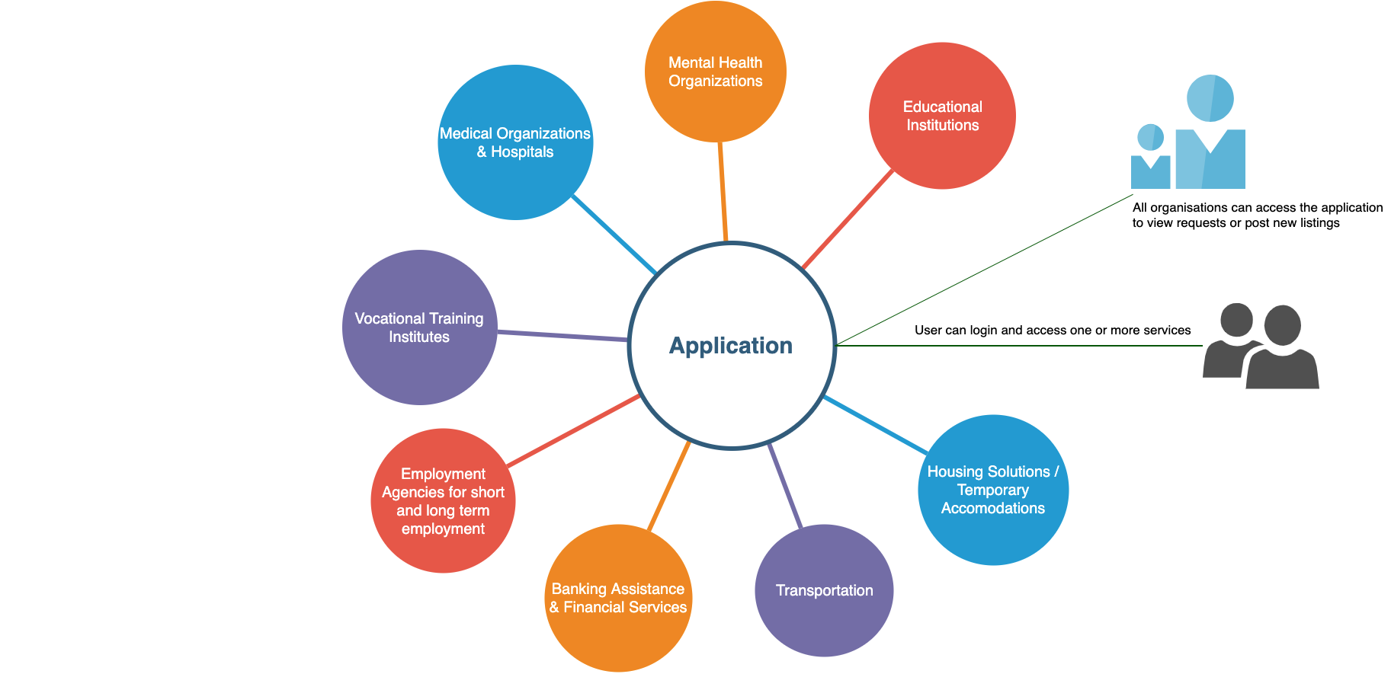

WorkAreas:

App User(Admin,CommonPeople,Veterans,Organisations/Banks) -- WorkAreas

Entities:

US Military

MyApp

US State Entities(Government)

AppUser

Funding Banks

Housing Banks

Health Banks(physical and mental)

Food Banks

Employment Banks

Local Support Groups

Veterans Society